## SQS (Simple Queue Service) :

Two types of SQS

Default: Message ordering is not guaranteed, and message can be delivered more than once.

FIFO: Message ordering is guaranteed and delivered only once.

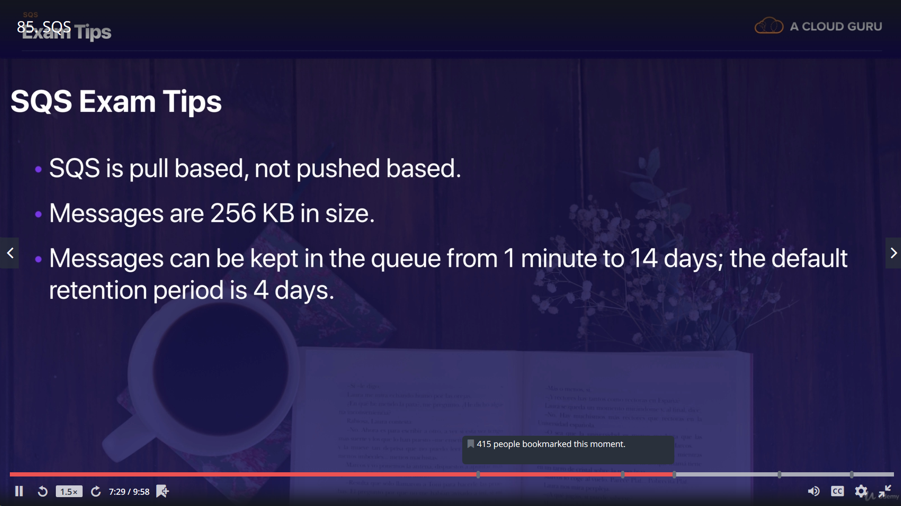

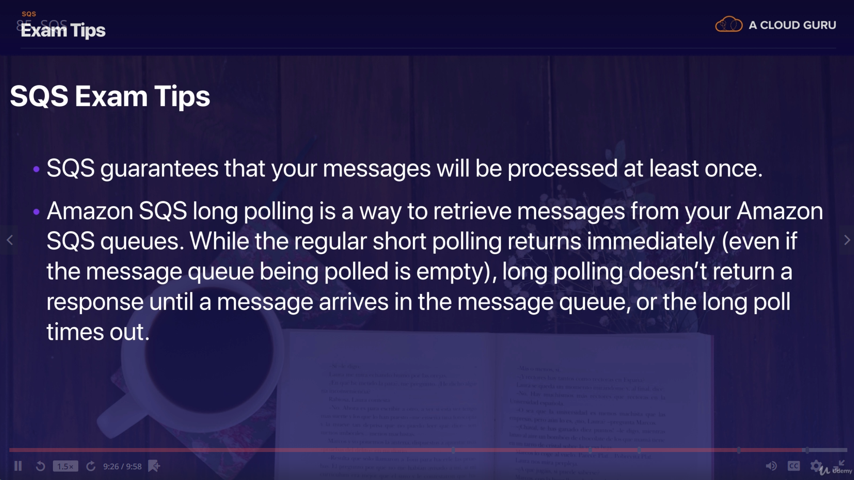

## SWF (Simple Workflow Service) :

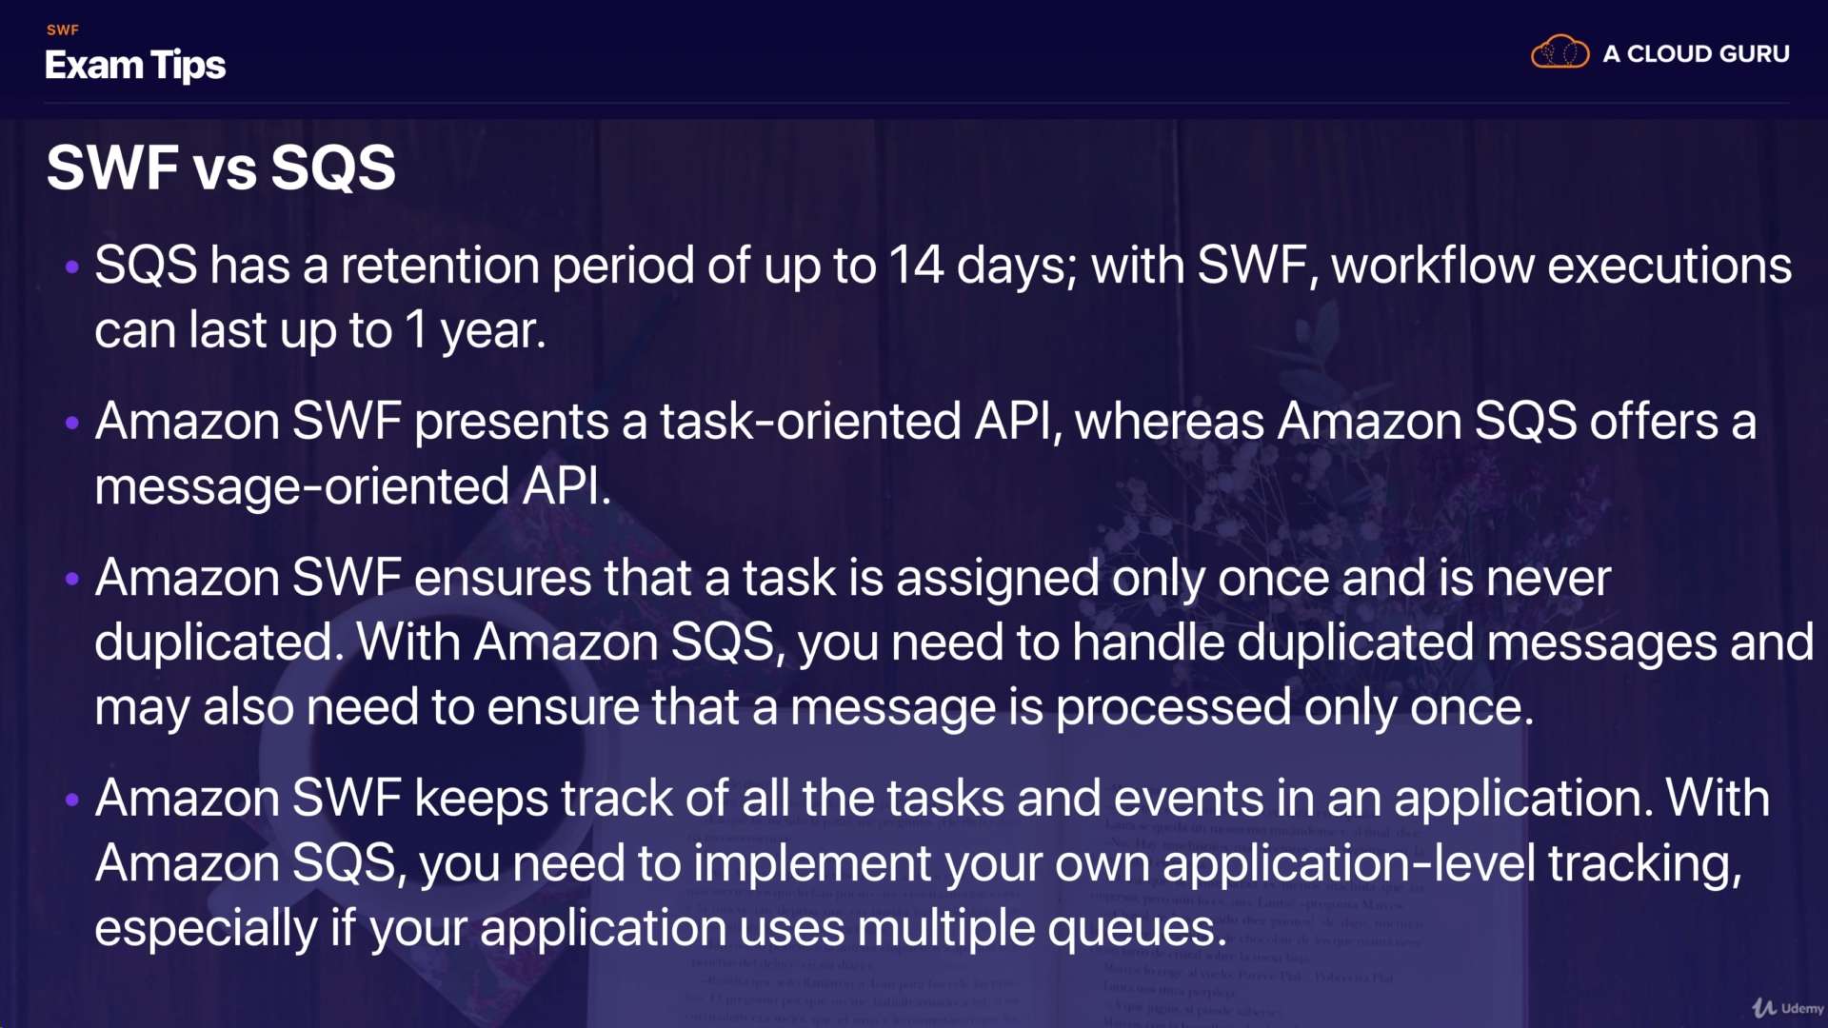

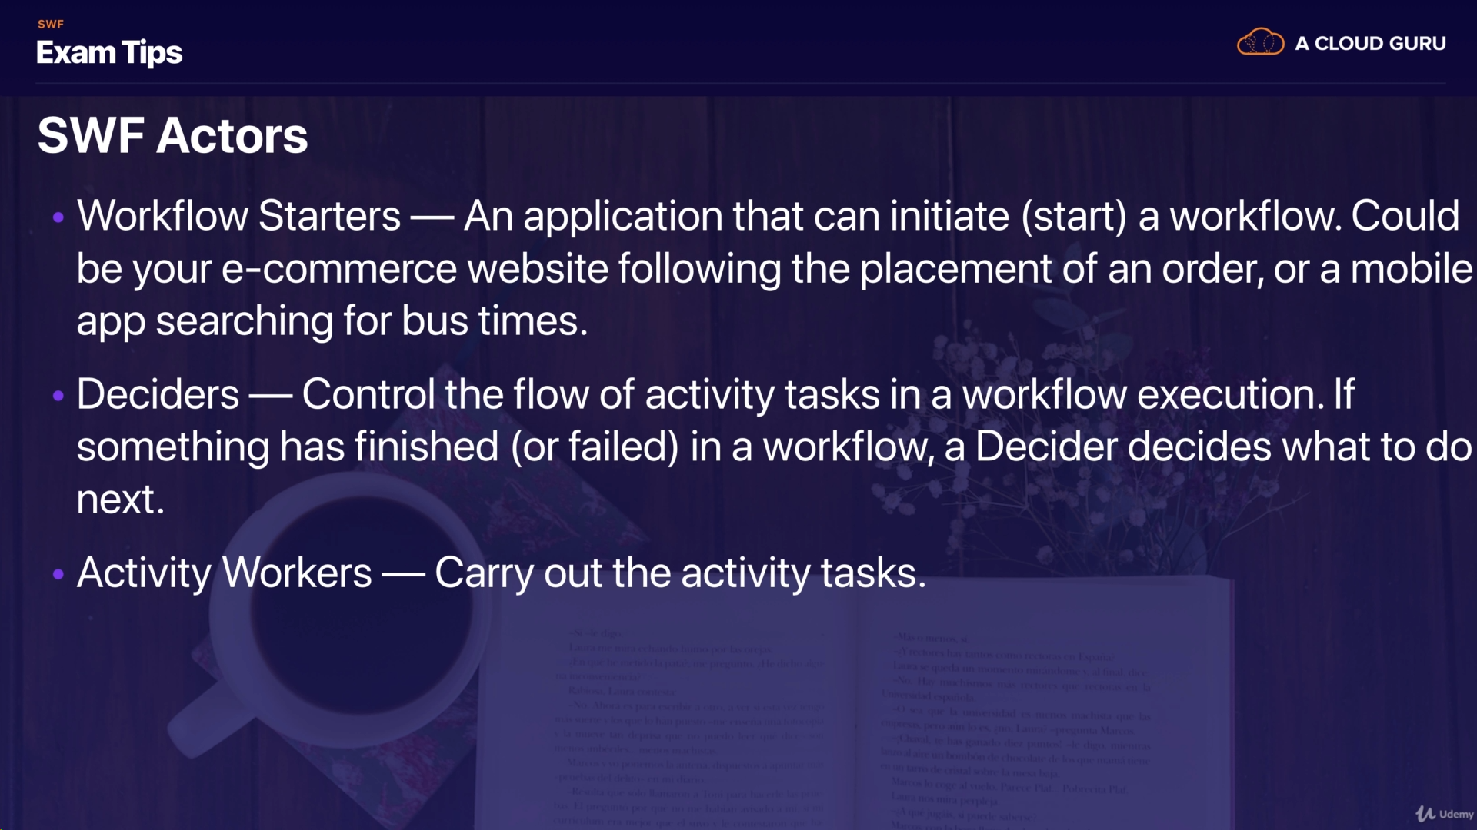

## SNS (Simple Notification Service):

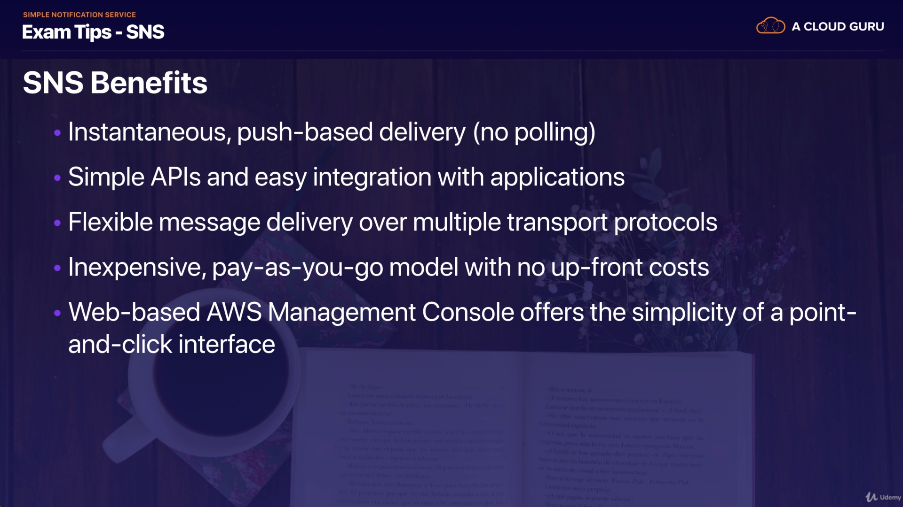

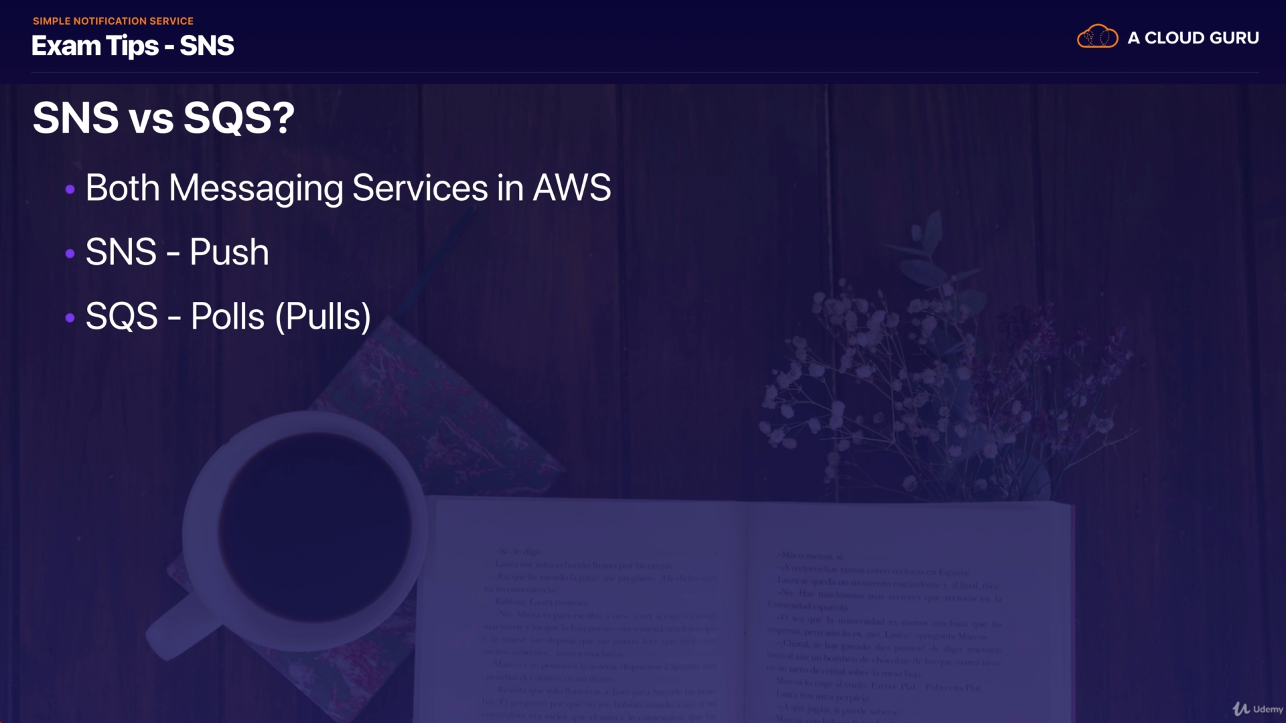

## Elastic Transcoder:

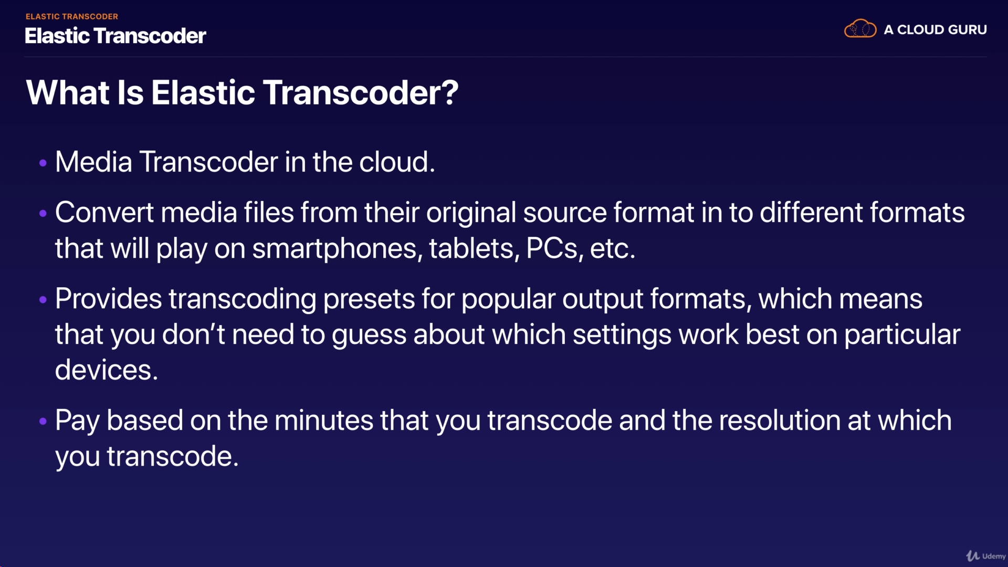

## API Gateway:

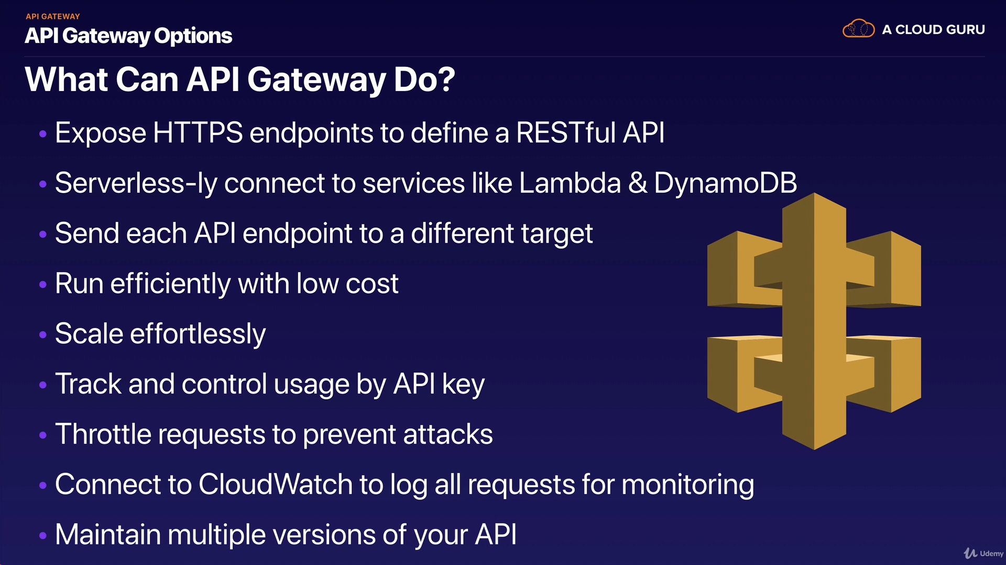

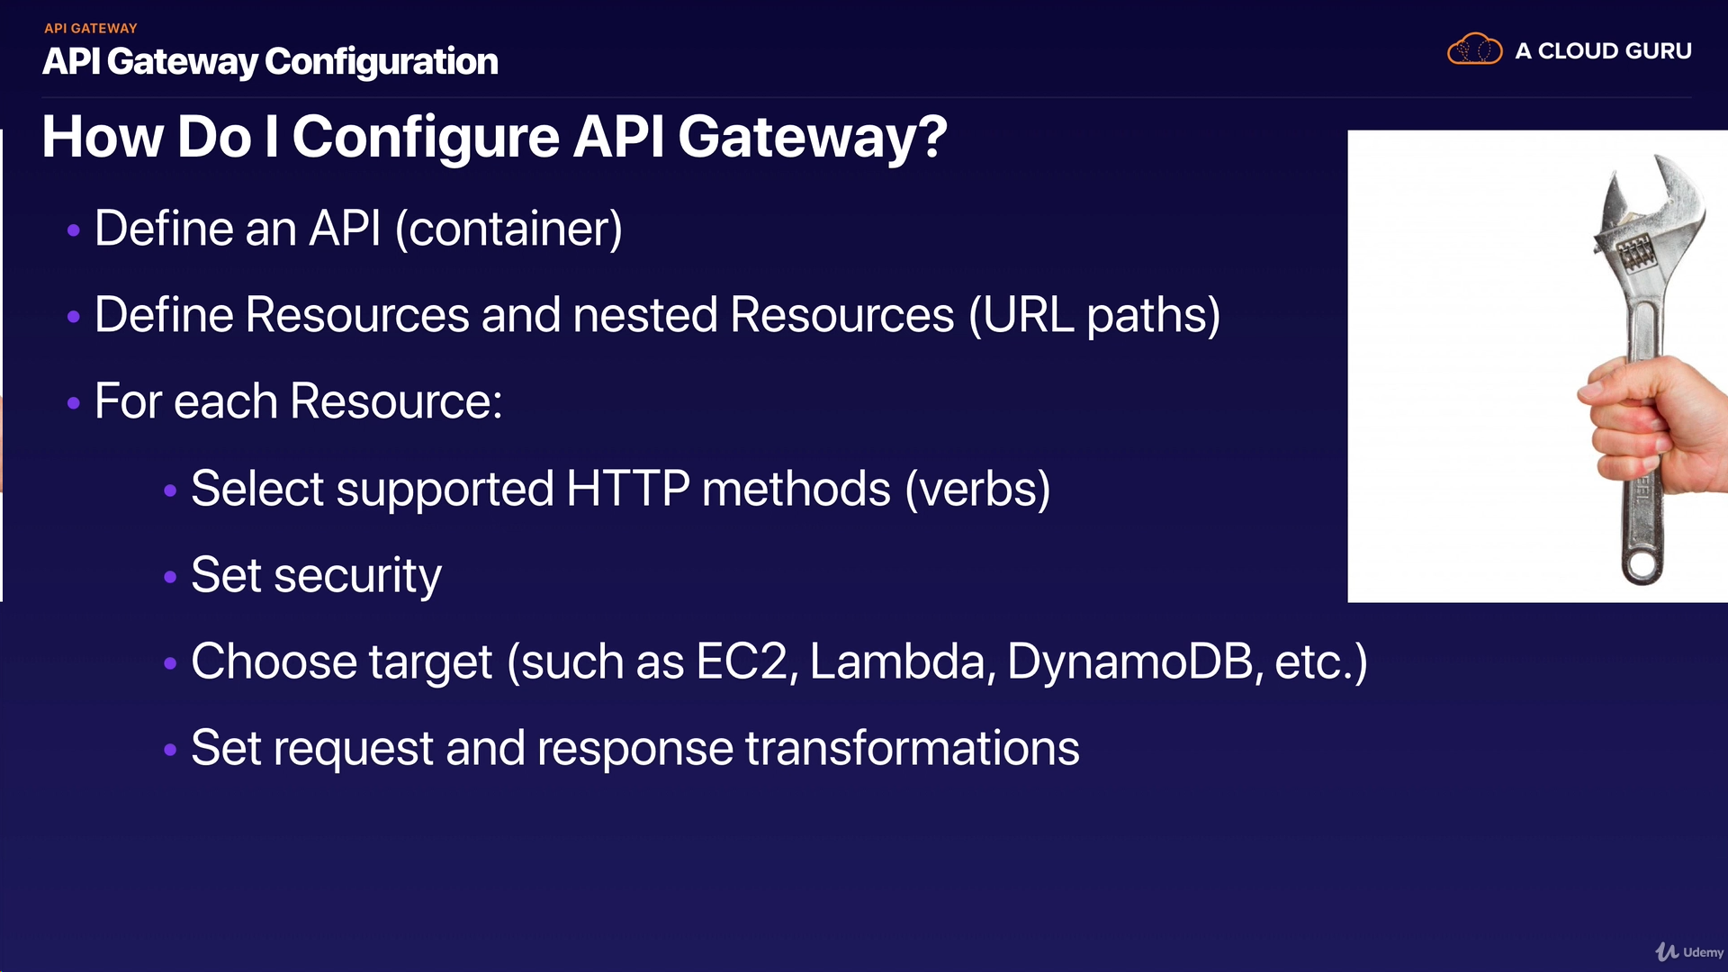

## Kinesis:

Three different types of Kinesis:

1. Kinesis Streams
2. Kinesis Firehose
3. Kinesis Analytics

